Nature's Navigators: Emulating Slime Mold Behavior in Algorithmic Design

Abstract ID: 6927

Amol M. Shirodkar, Chris Emmanuel E. Sadaya, Justin Cui, & Kogul Kathirgamathas

Department of Industrial and Systems Engineering, Rutgers University, New Brunswick, NJ, USA

Abstract

This project explores the remarkable pathfinding abilities of slime molds, organisms known for their efficient network optimization. Our study involves observing slime mold behavior within specially designed 3D printed grids of varying shapes, aiming to understand how these organisms navigate complex environments towards food sources. The core of our investigation revolves around meticulously analyzing the movement patterns and decision-making processes of the slime molds as they traverse these grids.

By leveraging these biological insights, we have developed a Python algorithm that replicates the slime mold's natural pathfinding strategies. This algorithm is grounded in the probabilistic models derived from our grid experiments, translating biological intelligence into a computational framework. The purpose is to harness the inherent optimization capabilities of slime molds for potential applications in network design, resource allocation, and route optimization problems.

The fusion of biological observation and algorithmic modeling in this project not only highlights the efficiency of slime mold navigation but also opens new avenues for bio-inspired computational techniques. Our findings contribute to a deeper understanding of natural optimization processes and demonstrate the practical potential of biomimicry in algorithmic development.

Keywords

Slime mold, path finding algorithms, 3D printing, network optimization.

# Introduction

In the quest for optimizing systems and networks, the field of Industrial and Systems Engineering (ISE) continually seeks innovative approaches to solve complex problems. This paper introduces a groundbreaking exploration of the untapped potential of slime molds, specifically *Physarum polycephalum*, in pathfinding and network optimization. Known for its brainless intelligence, *Physarum polycephalum* has demonstrated remarkable capabilities in navigating mazes, optimizing nutrient absorption, and even reconstructing the Tokyo rail network in an experiment, showcasing its efficiency in forming minimal yet effective pathways.

Our project delves into the slime mold's natural strategies to navigate and optimize paths within specially designed 3D printed grids. By closely observing and analyzing the organism's behavior in various grid shapes towards food sources, we have extracted valuable insights into its decision-making processes. These biological observations have informed the development of a Python-based algorithm that mimics the slime mold's pathfinding abilities, embodying the principles of biomimicry in computational design.

This interdisciplinary approach not only highlights the efficiency of slime mold navigation but also sets a precedent for leveraging biological systems in algorithmic development. Our findings hold promise for a wide range of applications in network design, resource allocation, and route optimization, underscoring the relevance and potential of bio-inspired techniques in addressing core ISE challenges.Top of Form

# Problem Description

The core problem addressed in this study revolves around the remarkable yet underexploited capabilities of slime molds, particularly *Physarum polycephalum*, in pathfinding and network optimization. The intriguing behavior of these organisms, capable of solving mazes and optimizing networks without a central nervous system, presents a unique opportunity for innovative solutions in Industrial and Systems Engineering (ISE), Computer Science, and Biology.

Our project aims to delve deep into the mechanisms by which slime molds navigate and proliferate within controlled environments. We have developed custom 3D printed grids to emulate complex networks and observe the slime mold's behavior in real-time. The primary challenge lies in translating the observed biological behaviors into quantifiable metrics that can be leveraged to enhance algorithmic models for network optimization.

To address this, we propose a detailed investigation into the probabilistic nature of slime mold movements and decision-making processes. By growing *Physarum polycephalum* in these bespoke grids, we aim to dissect and quantify their behavior, laying the groundwork for a Python algorithm that mirrors the slime mold’s natural pathfinding strategies. This algorithm will be grounded in the probabilistic models derived from our empirical observations, thereby bridging the gap between biological intelligence and computational algorithms.

This research-heavy project is driven by a personal interest in the intersection of ISE, Computer Science, and Biology. It holds significant potential for applications in network design, city planning, and biological research, offering a fresh perspective on solving traditional problems in these fields through bio-inspired computational techniques​.

# Related Research

The exploration of slime molds, particularly *Physarum polycephalum*, in computational and engineering contexts has garnered interest due to their unique pathfinding and network optimization capabilities. Our project draws upon and extends the existing body of research in this domain.

A significant contribution to the field is the work by Gharehchopogh et al. (2023), which provides a comprehensive survey of the Slime Mold Algorithm and its applications across various domains. This review highlights the versatility of slime mold-based algorithms in solving complex optimization problems, serving as a foundational pillar for our experimental approach in quantifying slime mold behavior within 3D printed mazes.

Complementing this, the study by Li et al. (2020) introduces the Slime Mold Algorithm as a novel method for stochastic optimization, emphasizing its potential in addressing a wide array of optimization challenges. The focus on stochastic optimization is particularly relevant to our project, as it aligns with our goal to understand and replicate the behavior of slime molds in maze-like environments for pathfinding purposes.

By integrating insights from these studies, our research aims to extend the application of slime mold behaviors from a theoretical framework to practical, experimental modeling. Our work involves the detailed observation of slime molds in 3D printed mazes, aiming to derive a computational model that simulates these biological processes for enhanced network optimization techniques​​.Top of Form

# Methodology

Our methodology harnesses the unique capabilities of slime molds, specifically *Physarum polycephalum*, to navigate and optimize paths within complex environments. We employed a two-pronged experimental design using custom 3D printed grids of various geometries to simulate diverse network configurations.

*First Experiment Design:*

We crafted five distinct types of grids to explore how slime molds navigate through different spatial challenges. Each grid was populated with nine slime molds, each provided with its own food source to simulate network nodes. Observations were conducted daily to track the molds' growth patterns and pathfinding strategies.

*Second Experiment Design:*

To deepen our understanding, we refined our approach with four grid types, focusing on individual slime molds' interactions with multiple food sources. This phase involved two setups: one with a slime mold placed between a primary food source and a secondary one, and another with additional food sources introduced. Observations were intensified to twice daily, enhancing the granularity of our data collection.

The grids, pivotal to our experimental setup, were meticulously designed using CAD and encompassed various geometries, including empty, rectangular, triangular, hexagonal, and a specialized Type #4 grid. These designs were instrumental in creating controlled environments that mimic real-world network complexities.

Data collection was rigorous, employing a blend of traditional observation and modern digital tools to record the molds' behavior. Metrics such as time to envelope food sources, growth initiation, path lengths, and growth rates were systematically recorded. This data formed the basis of our probabilistic models, capturing the nuanced decision-making processes of the slime molds in their quest for resources.

Our innovative use of 3D printing technology to create these growth environments not only facilitated a novel approach to studying biological systems but also underscored the potential of integrating such methodologies into broader research and practical applications in network optimization, city planning, and biological studies.

# Results

Our research yielded significant findings regarding the behavior of *Physarum polycephalum* in navigating complex grids, leading to the development of a probabilistic model that underpins our Python-based slime mold algorithm. The key results from our experiments are summarized in the sections that follow.

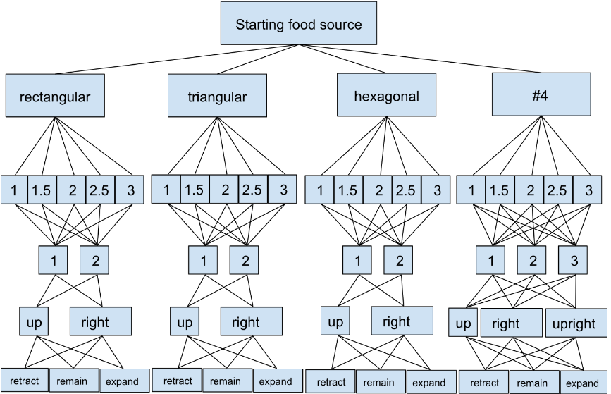

Figure 1: Probability tree mapping out the experimental design. The levels, starting from the top, are the initial food source, the grid types, days to envelope the food source, number of splitting paths, direction of connecting paths, and behavior after connection.

*Enveloping Time:*

The time taken by slime molds to completely envelop their initial food sources varied across grid types, with observed times ranging from 1 to 3 days. For instance, in triangular grids, the likelihood of enveloping occurring within a day was 50%, while in rectangular grids, this likelihood was 16.67%. This variation highlights the impact of grid geometry on slime mold behavior​​.

Table 1: Times for enveloping food source sorted by grid type

|  |  |  |  |  |
| --- | --- | --- | --- | --- |
| Time (days) | Rectangular | Triangular | Hexagonal | #4 |
| 1 | 16.67% | 50.00% | 25.00% | 0.00% |
| 1.5 | 50.00% | 0.00% | 25.00% | 75.00% |
| 2 | 0.00% | 25.00% | 50.00% | 25.00% |
| 2.5 | 16.67% | 25.00% | 0.00% | 0.00% |
| 3 | 16.67% | 0.00% | 0.00% | 0.00% |

*Number of Splitting Paths:*

Our observations on the number of splitting paths during the slime molds' search for food revealed significant differences based on grid type. For example, in rectangular grids, 94.44% of observations noted two splitting paths, while in triangular grids, a single path was observed 77.5% of the time, indicating diverse strategies in resource exploration​​.

Table 2: Number of branching paths from starting food source sorted by grid type

|  |  |  |  |  |
| --- | --- | --- | --- | --- |
| # Paths | Rectangular | Triangular | Hexagonal | #4 |
| 1 | 5.56% | 77.50% | 63.33% | 47.92% |
| 2 | 94.44% | 22.50% | 36.67% | 45.83% |
| 3 | - | - | - | 6.25% |

*Direction of Connecting Branch:*

The analysis of the direction taken by the connecting branches of slime molds towards new food sources showed a preference based on grid layout. In triangular grids, 100% of the connections were made to the right, while in hexagonal grids, 50% of connections were made upwards, suggesting an innate ability to adapt to spatial constraints​​.

Table 3: Direction of connecting paths sorted by grid type

|  |  |  |  |  |
| --- | --- | --- | --- | --- |
| Direction | Rectangular | Triangular | Hexagonal | #4 |
| Up | 33.33% | 0.00% | 50.00% | 33.33% |
| Right | 66.67% | 100.00% | 50.00% | 33.33% |
| Up & Right | - | - | - | 33.33% |

*Behavior After Connection:*

Post-connection behavior varied significantly, with some slime molds retracting, remaining static, or expanding. For instance, in rectangular grids, all observed slime molds retracted post-connection, whereas in hexagonal and Type #4 grids, there was a 50% chance of expansion, pointing towards adaptive growth strategies following resource acquisition​​.

Table 4: Behavior of slime following connection sorted by grid type

|  |  |  |  |  |
| --- | --- | --- | --- | --- |
| Behavior | Rectangular | Triangular | Hexagonal | #4 |
| Retract | 100.00% | 0.00% | 50.00% | 66.67% |
| Remain | 0.00% | 50.00% | 0.00% | 0.00% |
| Expand | 0.00% | 50.00% | 50.00% | 33.33% |

*Comprehensive Analysis and Algorithm Development:*

Across over 40 experimental setups, we systematically extrapolated critical metrics from our observations, such as enveloping time, number of splitting paths, direction of connecting branches, and post-connection behavior. These metrics informed the development of a probabilistic model, which was then implemented in a Python algorithm to simulate the behavior of slime molds through their growth stages. This algorithm serves as a testament to the potential of bio-inspired computational models in solving complex pathfinding and network optimization problems​​.

These results not only underscore the adaptability and efficiency of slime molds in navigating and optimizing paths within varied environments but also demonstrate the feasibility of translating biological phenomena into computational algorithms for practical applications in network design and optimization.

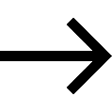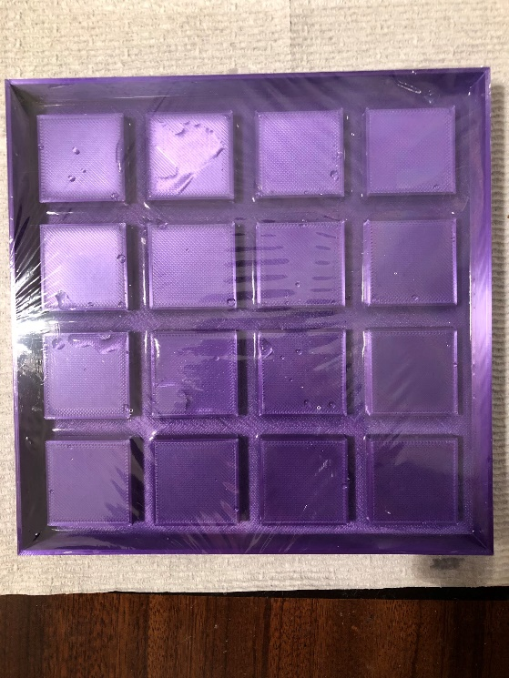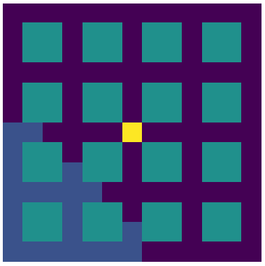

Figure 2: A parallel is drawn between the physical test grid we used and the Python simulation of slime molds in a grid created using Matplotlib, where the central yellow square is the food source and dark blue is the slime mold.

# Conclusions

In conclusion, our research delves into the remarkable capabilities of slime molds, specifically *Physarum polycephalum*, to navigate and optimize paths within complex networks. By conducting a series of experiments within custom-designed 3D printed grids, we have uncovered intricate behaviors of slime molds that reflect their efficiency in pathfinding and network optimization. These behaviors include varied enveloping times, distinct patterns in splitting paths, directional preferences in connecting branches, and adaptive post-connection growth strategies, all of which are influenced by the geometrical constraints of their environments.

From a technical perspective, the quantification of these behaviors has allowed us to develop a probabilistic model that accurately reflects the decision-making processes of slime molds. The translation of this model into a Python-based algorithm demonstrates the feasibility of applying biological principles to computational problems, specifically in the realms of pathfinding and network optimization.

From an industrial standpoint, the implications of this research are vast. The insights gained from the slime molds' natural optimization strategies can inform the design of more efficient network systems, improve resource allocation methodologies, and enhance route optimization algorithms. The interdisciplinary nature of this study, bridging biology, computer science, and industrial and systems engineering, underscores the potential of bio-inspired approaches in addressing complex engineering challenges.

In essence, our study not only highlights the efficiency and adaptability of slime molds in overcoming environmental challenges but also opens new avenues for bio-inspired computational techniques. The successful replication of these natural strategies in a computational framework paves the way for innovative solutions in network design and optimization, offering promising prospects for future research and practical applications in various industries.

Acknowledgements

We would like to acknowledge Dr. Mohsen Jafari, Patrick Rudawski, and the Department of Industrial and Systems Engineering at Rutgers University, New Brunswick for all their guidance and funding when completing this project. We would also like to acknowledge Dean J. D. Bowers and the Rutgers Honors College for their continued support of our academic ventures and for providing us with a platform to share our insights.

References

1. S. Li, H. Chen, M. Wang, A. A. Heidari, and S. Mirjalili, “Slime mould algorithm: A new method for stochastic optimization,” *Future Generation Computer Systems*, vol. 111, pp. 300–323, Oct. 2020, doi: <https://doi.org/10.1016/j.future.2020.03.055>.
2. Farhad Soleimanian Gharehchopogh, Alaettin Ucan, Turgay Ibrikci, Bahman Arasteh, and G. Isik, “Slime Mould Algorithm: A Comprehensive Survey of Its Variants and Applications,” vol. 30, no. 4, pp. 2683–2723, Jan. 2023, doi: <https://doi.org/10.1007/s11831-023-09883-3>.
3. J. Yang, Y. Zhang, T. Jin, Z. Lei, Y. Todo, and S. Gao, “Maximum Lyapunov exponent-based multiple chaotic slime mold algorithm for real-world optimization,” *Scientific Reports*, vol. 13, no. 1, Aug. 2023, doi: <https://doi.org/10.1038/s41598-023-40080-1>.
4. F. Jabr, “How brainless slime molds redefine intelligence,” *Nature*, Nov. 2012, doi: <https://doi.org/10.1038/nature.2012.11811>.
5. J. Vallverdú *et al.*, “Slime mould: The fundamental mechanisms of biological cognition,” *Biosystems*, vol. 165, pp. 57–70, Mar. 2018, doi: https://doi.org/10.1016/j.biosystems.2017.12.011.